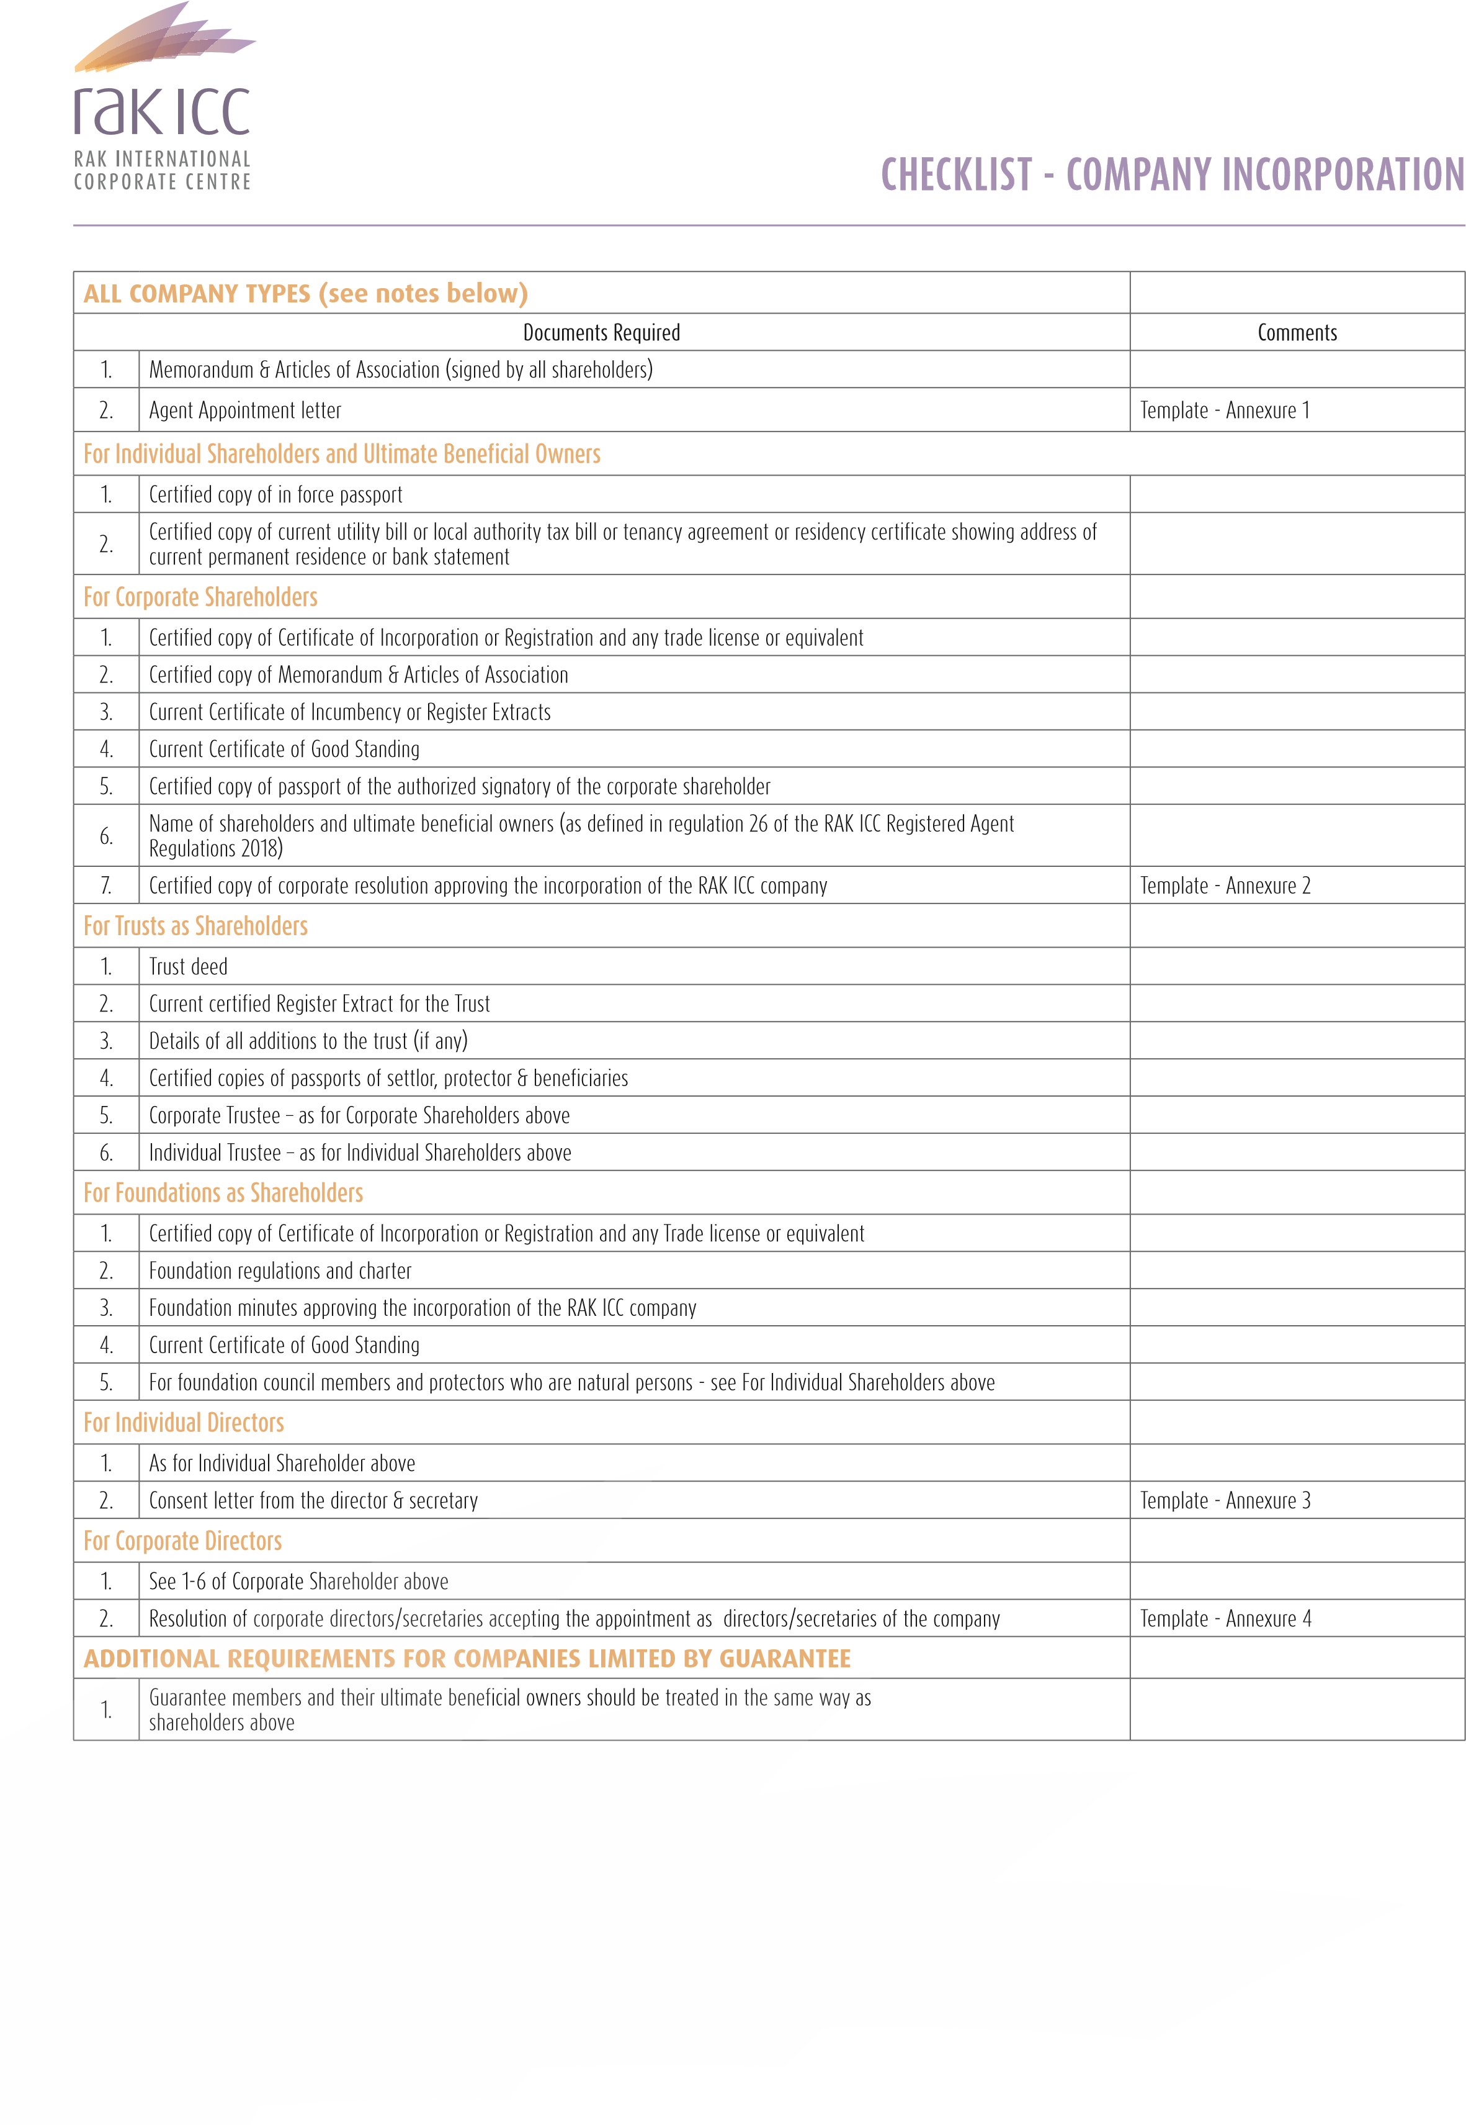

|  |  |  |
| --- | --- | --- |
| **ADDITIONAL REQUIREMENTS FOR SEGREGATED PORTFOLIO COMPANIES (SPCs)** | |  |
| 1. | Application form |  |
| 2. | Business plan of the SPC |  |
| 3. | Evidence of knowledge and expertise | Regulation 142 of BCR |
| **ALL TYPE OF COMPANY** | |  |
| 1. | Ultimate beneficial owner and Nominee declaration form. *(Template attached here)* |  |

NOTES:

1. If the Memorandum & Articles of Association are signed wholly within the UAE, please provide an undertaking letter from the registered agent. Template attached under Annex 5.
2. In case the documents are signed under a Power of Attorney, then provide a passport copy of the person signing under the POA along with valid copy of POA.
3. Documents in foreign languages must be accompanied by duly certified English or Arabic translations. 5. Documents which must be current should be dated within 3 months from the date of the application.
4. All documents must be duly signed and stamped by registered agent; copies must be certified by the registered agent or a notary.
5. The Registrar reserves the right to call for additional documents.
6. In addition to providing the documents above, it is the responsibility of Registered Agents to comply with regulation 26 of the RAK ICC Registered Agent Regulations 2018 and applicable UAE law (including as regards the prevention of money laundering and terrorist finance).
7. All documents and declared information will be subject for inspection by the Registry.

1. Template for Agent appointment letter

Date

To,

The Registrar

RAK International Corporate Centre

Government of Ras Al Khaimah

P.O. Box 30099

Ras Al Khaimah

UAE

Re: Appointment as Registered Agent

I hereby confirm that I have appointed ____________[Registered Agent name & address]_____________ as the Registered Agent of the International Business Company, ____________________[New RAKICC Company Name]_____________________, to be formed in my/our name(s).

Yours sincerely

Name of Shareholder _______________________________________________

Signature of Shareholder

2. Template for Corporate Resolution approving the incorporation of the RAK ICC Company

Resolution Of The Shareholder(S) Of ______________[Corporate Shareholder Name]______________

Registration number:_______________

Minutes of Meeting of the company held at the Registered Office at _____________________[Registered Address]_________________________________________

held on the day of 20

IT WAS RESOLVED:

1. TO incorporate a new International Business Company under the

Ras Al Khaimah International Corporate Centre Business Companies Regulations 2018 under the name __­­­­_______[New RAKICC Company Name]____________

or any other name as approved by the authority.

2. THAT __________________[Corporate Shareholder Name]___________________will be the sole shareholder of the proposed new Ras Al Khaimah International Business Company, ­­­­­­­­­­___________[new RAKICC Company name]_______________ with ____ shares of [Currency]_______ each.

3. TO appoint _________[name of authorised signatory]________ , ______[nationality] national, Passport No. _____[passport #]_____ & _____[name of authorised signatory]____ , ______[nationality] ___ national, Passport No. ______[passport #]________

as authorized signatories on behalf of the company to singly sign incorporation documents of the proposed new Ras Al Khaimah International Business Company, ______[New RAKICC Company Name]_____.

4. THAT __________[name of authorised signatory]­­________ , ______[nationality] ___ national, Passport No. ______[passport #]______ will be appointed as Director & Secretary of the proposed new Ras Al Khaimah International Business Company, ______[new RAKICC Company name]­­­_____.

5. There being no other business, the meeting was declared closed.

Signed on: ­­­­________________________________________

Name & Signature of Shareholder: _________________________________________

3. Template Consent Letter from Individual Director & Secretary

Date

To,

The Registrar

RAK International Corporate Centre

Government of Ras Al Khaimah

P.O. Box 30099

Ras Al Khaimah UAE

Sub: Consent letter

I hereby accept my appointment as ­­­­________Director [& Secretary] ______of ______[New RAKICC Company Name]_____.an international business company proposed to be incorporated at RAK International Corporate Centre, Ras Al Khaimah, United Arab Emirates.

I confirm that my appointment will be effective from the date of incorporation of ______[New RAKICC Company Name]_____.

Yours sincerely

Name of Director (/Secretary): ___________________________________

Signature of Director(/Secretary): _________________________________

4. Template for Corporate Resolution from new corporate director/corporate secretary

# CORPORATE DIRECTOR / SECRETARY LETTERHEAD

Registration No.

Resolution of the [Shareholder(s)

/ Director(s)] of the above mentioned company registered in the _________________[Name of jurisdiction] _____________________at ____­­­­­­­­­­_______________[ registered address]___________________________.

The shareholder of the above mentioned company (hereinafter ‘the company’) with Registration No. ________________ incorporated on _______[day] [month] [year]____ adopted the following resolutions:

IT WAS FURTHER RESOLVED that, subject to approval of the RAKICC Registrar, the Company accepts the appointment as corporate director/corporate secretary of _____[COMPANY NAME]____.

There being no other business, the meeting was declared closed.

I / We, the undersigned being authorised to sign on behalf of the Company, hereby adopt this Resolution on _______[day] [month] [year]____.

Name of the Director _______________________________________________

Authorised signatory

Designation / Position in Authority ______________________________________

5. Template for Witnessing signatures by registered agent

TO BE PRINTED ON REGISTERED AGENT LETTERHEAD

Date

To,

The Registrar

RAK International Corporate Centre

Government of Ras Al Khaimah

P.O. Box 30099

Ras Al Khaimah

UAE

Sub: Confirmation on witnessing signature

This is to confirm that I, [name of the person witnessing the signing],__________________________________________________________________________

[Designation] of [Registered Agent Name] on __________[date] have witnessed the signing of the relevant documents for [name of the company] by [name of the client signing], the [shareholder / director] of the said company.

Yours sincerely

Registered Agent Name ______________________________________

Signature